2024
Everything you need to know
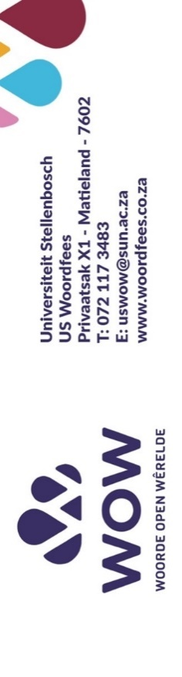

Dear Principal/Subject Head: English / Educator
National Finals: 28 September at Stellenbosch University
What? | To present Sanlam WOW spelling festivals according to the prescribed format:  - In each class and  - In each grade of the participating school,  - As well as in circuits, districts, provinces and at a national level.
Why? | - To expand language knowledge and vocabulary for learners, and  - To encourage effective language use  - To address learning losses  - To strengthen learner achievement  - To identify excellence
When? | Registration closes: 31 May 2024  Spelling festivals: July – September  Online spelling tests: March – December
Where? | In-person, venues will be indicated
Who? | All interested schools
How? | In-person spelling festivals
What do I do now?...  Click and choose | See below and please enter  In-person spelling tests:  See links  Online spelling tests:  https://wow.woordfees.co.za/wat-ons-doen/
Please remember: | In-person:  Schools register and indicate who the co-ordinator(s) is/are  Further details will be sent to schools:
Spelling lists? | Spelling lists are sent or can be downloaded from 18 March at https://wow.woordfees.co.za/wat-ons-doen/
Spelling Festivals: Provincial (dependent on the registrations) | - Gauteng: Johannesburg  - Limpopo: Mokopane  - KwaZulu-Natal: Durban  - Mpumalanga: Middelburg  - Northern Cape: Upington  - Northwest: Brits  - Eastern Cape: Gqeberha  - Free State: Bloemfontein  - Western Cape: Stellenbosch

Please contact us at: uswow@sun.ac.za. We look forward to receiving your entry
Let us all join in and have fun spelling!

In-person Spelling Festival:  - For English, Grades 5 to 9  Afrikaans, Grades 1 to 10  isiXhosa, Grades 6 to 8  - . Preparation: Spelling lists are available on the WOW project website  https://wow.woordfees.co.za/wat-ons-doen/  - Entry is free  Register for Afrikaans:  http://surl.li/rlasc  Register for Engels:  http://surl.li/rlaqx  Register for isiXhosa:  http://surl.li/rlasy | - In-person Spelling Festival:  July to September:  - Registration: school register electronically through the link (see links on the left)  - Registrations close on 31 May 2024.  - The format and rules will be available on the website.  - The dates of the spelling festival will be announced on the website and will also be communicated directly to the schools (as entries are received.)  - National finals: 28 September 2024  - English: Grades 5 to 9  Afrikaans: Grades 1 to 10  isiXhosa: Grades 6 to 8  - At Stellenbosch University
Online Spelling Tests:  - For English, Grades 5 to 9  Afrikaans, Grades 1 to 10  isiXhosa, Grades 6 to 8  - Preparation: Spelling lists are available on the WOW project website.  https://wow.woordfees.co.za/wat-ons-doen/  - Entry is free. | - Online Spelling tests with 10 point tests:  - Registration: schools/individual learners register here: https://wow.woordfees.co.za/wat-ons-doen/  - Completion of tests:  - Learners must enter individually and complete the spelling test.  - It is recommended that learners complete the entire test on their own.  - Only learners who complete all tests will receive a notification of participation.  - Sanlam WOW Spelling 50-POINT Test (Online):  - An online spelling test will be available for use as needed.  - Format for participation:  - Learners enter and complete spelling test.  - Learners can complete the tests as regular as needed.  - Answer as many of the questions as you can.  - It is recommended that learners complete the full spelling test.  - Time: no time limit – learners can complete test at own pace.  Participants will receive no proof of participation notice.
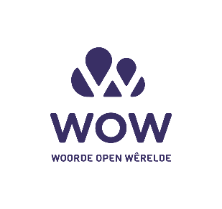
Keep an eye out at our Facebook and Instagram pages for more information about this wonderful project action.

