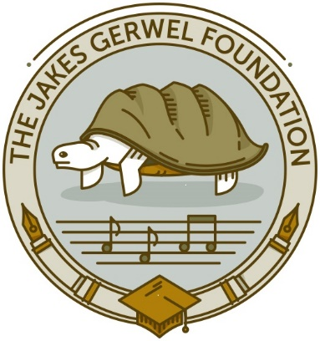

MENTORSHIP PROGRAMMES 2022: APPLICATION FORM

- PERSONAL INFORMATION
Name & Surname
ID number
Cell nr
E-mail
Home address

- SELECTED PROGRAMME
Select your preferred programme below. Please make sure you submit the requested documents with your application form by the specific closing date.
1 | Programme for Upcoming Writers (Fiction / Non-Fiction)  - Submit manuscript of 30,000  - No specific deadline
2 | Programme for Song writers  - Examples of lyrics and songs  - Motivation Letter  - Short bio  - Closing date: 15 July 2022
3 | Kommadagga – Short Prose  - Short story of 2,000 words  - Motivation Letter  - Short bio  - Closing date: 10 June 2022
4 | Residency for PEN Members  - Only for PEN (Afrikaans / South Africa) members  - Detailed Project Plan  - Motivation Letter  - Short bio  - Published writers must submit a publication list, while upcoming writers must submit 30 pages prose / 10 pages poetry.  - A Reference Letter of the Publisher (not obligatory)  - Closing date: 18 March 2022
5 | Dialogue Programme – Flemish / South African  - Detailed Project Plan  - Motivation Letter  - Short bio (examples of previous / new work)  - Closing date: 5 September 2022
6 | NATi Rising Stars – playwrights  - Extract or full play  - Motivation Letter  - Short bio  - Closing date: 27 May 2022

- REQUIREMENTS

- Only email applications will be considered
- Send your application to Theo Kemp - theo@jgf.org.za
- No late applications will be considered
- Only completed applications, with all requested documents, will be considered
- Except for the PEN and Dialogue Programme, only upcoming writers may apply for the mentorship programmes.

