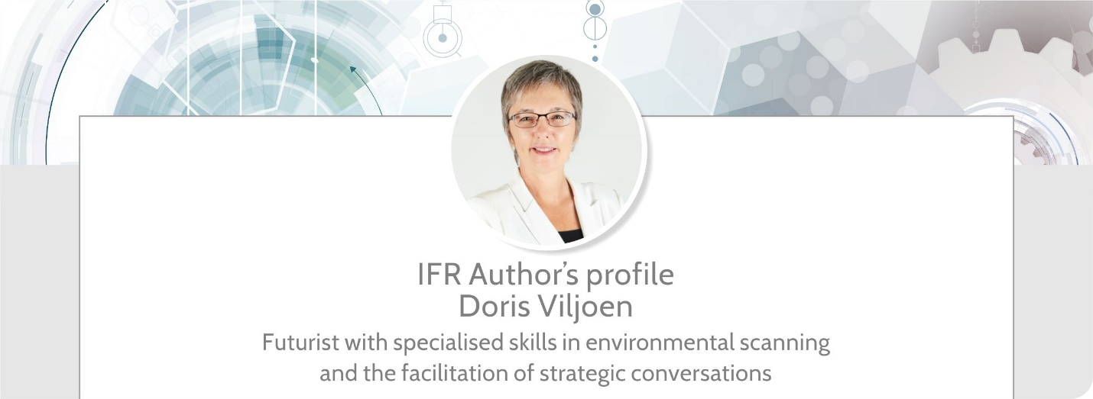

Doris Viljoen is a senior futurist at the Institute for Futures Research, with specialised skills in foresight, strategy development and environmental strategic awareness. She has consulted to leading listed organisations in South Africa and abroad. Furthermore, she is a senior lecturer on the Futures Studies programmes of the University of Stellenbosch Business School.

She is a curious, forever-learning optimist, passionate about thinking with leaders to connect the ‘dots on the horizon’. As Senior Futurist, she endeavours to interpret global trends and assess their relevance for South Africa and Africa.

Doris has post-graduate qualifications in business management, education, project management as well as Futures Studies.

She has a wide range of research interests and is passionate about asking the right questions, searching for, and finding the data that could inform decisions and sharing the results of her findings in the interest of providing clients with strategic advantage. She is well versed in multiple scenario planning techniques and has facilitated decision making teams through scenario exercises on topics ranging from infrastructure planning, higher education, and downstream metals beneficiation to the future of work in South Africa.

As speaker, she is able to turn abstract concepts into digestible and actionable pieces of information. Her presentations mostly focus on the emerging ‘dots on the horizon’ and she guides decision-makers toward options for shaping their preferred futures.

