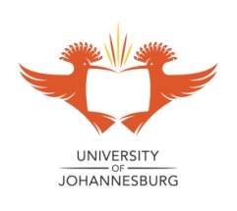
Department of Languages, Cultural Studies and Applied Linguistics
School of Languages

You are invited to a seminar presented by
Tongshinung Goteng
Doctoral candidate (Applied Linguistics, UJ)
Department of English Language, Plateau State University, Nigeria
11:00 for 11:15 on Monday, 20 November 2017
B Ring 513

The Implementation of English as a Medium of Instruction
in Higher Education in Nigeria

The demand for education through English as the medium of instruction by students and countries is gaining currency as well as its importance as a globalised medium of communication in multilingual contexts. The English language today is arguably the world’s common medium of communication. Its importance is further extended by the assumption that an English education is key to personal and national development. English education is seen to promote scholarship, science and technology and international commerce, and it is widely believed that it facilitates modernisation. Many countries, including Nigeria, have opted for English as the medium of instruction against this particular backdrop.
My study examined the scope of the implementation of Nigeria’s English Medium of Instruction policy (EMI) in three public universities, located in three different parts of the country. English is a second language in multilingual Nigeria. Some 520 languages are used in Nigeria, but the government’s language-in-education policy recognises English as the only medium of instruction at the higher levels of teaching and learning. The study focused on students’ and teachers’ perceptions of the use of English as a medium of instruction, in particular regarding their perceptions of the utilitarian value of the language as an instrument for personal career development. This seminar will discuss the findings from the study and offer recommendations that may benefit the government, language planners and policymakers, curriculum developers, students and teachers alike.

RSVP: Trudie Strauss by 17 November 2017 at trudis@uj.ac.za

